MAHATMA GANDHI MEMORIAL COLLEGE
UDUPI-576102

2025-2026
P.G DEPARTMENT OF COMPUTER SCIENCE

Mini Project Report on
Classification Of Music Instruments Using Machine Learning

Submitted By
Pavan
P05MG24S038016

Under the supervision of
Mr. B.P Damodar Pai
Assistant Professor
P.G Department of Computer Science
Mahatma Gandhi Memorial College
Udupi-576102

For the partial fulfillment of completion of
Master of Science (Computer Science)
2025-2026

MAHATMA GANDHI MEMORIAL COLLEGE
UDUPI – 576102
POST GRADUATION
DEPARTMENT OF COMPUTER SCIENCE

CERTIFICATE
This is to certify that the mini project entitled “Classification Of Music Instruments using Machine Learning” has been carried out by Pavan (Reg No: P05MG24S038016), student of third semester MSc (Computer Science) under the supervision of Mr. B.P. Damodar Pai, Assistant Professor, PG Department of Computer Science, Mahatma Gandhi Memorial College, Udupi. This dissertation is submitted in partial fulfilment of the requirement for the award of Master of Science (Computer Science) by Mangalore University during the Academic year 2025-2026.

Guide Head of the Department Vice Principal Principal
Mr. Damodar Pai Dr. Rekha N Chandra Dr. Vishwanath Pai Prof. Vanitha Mayya

Internal Examiner External Examiner

Submitted for the viva-voice examination held on: ……………

ABSTRACT

Automatic recognition of musical instruments is a key task in the field of music information retrieval and audio signal processing. This project focuses on developing a robust system for classifying musical instruments from audio recordings using machine learning techniques. Audio data from six different instruments including saxophone, flute, cello, trumpet, oboe, and viola is preprocessed to extract Mel-Frequency Cepstral Coefficients (MFCCs), which provide a compact representation of the spectral characteristics of sound. Multiple machine learning models, including Support Vector Machines (SVM), K-Nearest Neighbors (KNN), AdaBoost, and XGBoost, are trained and evaluated to identify the instrument corresponding to a given audio sample.

Content
Chapter No. | Chapter Name | Page No
1. | Introduction  - Introduction to the Project  - Problem statement  - Scope of the project | 1
2. | Literature review | 2
3. | Objectives | 3
4. | Methodology  4.1 Software and Hardware Specification  4.2 Dataset Loading  4.3 Feature Extraction  4.4 Data Preprocessing  4.5 Model Training  4.6 Model Evaluation | 4-6
5. | Results and Discussion  5.1 KNN Classifier  5.2 SVM Linear Classifier  5.3 RBF SVM Classifier  5.4 XGBoost Classifier  5.5 AdaBoost Classifier  5.6 Accuracy Comparison  5.7 Desktop Application Integration for Music Instrument Classification | 7-13
6. | Conclusion and Future Scope  6.1 Conclusion  6.2 Limitation  6.3 Future Scope | 14
 | References | 15

List of figures
Sl.No | Title | Page No
1. | KNN Confusion Matrix | 7
2. | SVM Linear Confusion Matrix | 8
3. | RBF SVM Confusion Matrix | 9
4. | XGBoost Confusion Matrix | 10
5. | AdaBoost Confusion Matrix | 11
6. | Accuracy Comparison of Machine Learning | 12
7. | Desktop Application Integration for Music Instrument Classification | 13

List of tables
Sl.No | Title | Page No
1. | KNN Classification Report | 7
2. | SVM Linear Classification Report | 8
3. | RBF SVM Classification Report | 9
4. | XGBoost Classification Report | 10
5. | AdaBoost Classification Report | 11

1. Introduction

  - Introduction
Music is a universal art form, It consists of fundamental elements such as sound, rhythm, tempo, dynamics, melody, harmony, and texture. These elements work together to form the building blocks of musical compositions, making music rich and varied across cultures and genres. Musical instruments are the tools we use to make music. They vary widely in how they generate sound, leading to different classifications such as string instruments, wind instruments, percussion, and electronic instruments. Different instruments create sound in different ways, each instrument has its own unique sound that helps bring music to life. Together, music and instruments allow people to express emotions, tell stories, and enjoy sound in many different forms.

  - Problem statement
Accurately classifying musical instruments from audio recordings is a challenging task due to the variability in sound characteristics and overlapping features among different instruments. Existing methods often struggle with generalization and robustness, especially when dealing with real-world audio data. This project addresses the problem of automatically identifying musical instruments—saxophone, flute, cello, trumpet, oboe, and viola—from audio samples using machine learning algorithms, including KNN, SVM, AdaBoost, and XGBoost.

  - Scope
This project is important because it helps automatically identify different musical instruments from audio recordings, which makes music sorting, searching, and learning much easier.

2. Literature Review
Prabavathy et al. (2020) [1] proposed a musical instrument classification system using Support Vector Machine and k-Nearest Neighbor algorithms. They extracted features using MFCC, Sonogram, and their combination, achieving high accuracy of 99.29% with SVM using combined features. SVM consistently outperformed kNN across all feature sets in precision, recall, and F-score.

Gulhane et al. (2020) [2] presented a musical instrument identification system that utilizes MFCC for feature extraction combined with two classifiers, K-Nearest Neighbor and Support Vector Machine. The experiment showed that MFCC features with SVM classifier provided high accuracy compared to KNN. Included noise removal and preprocessing significantly contributed to improved performance.

Deng and Ko (2022) [3] used a support vector machine achieved about 81% accuracy, which reduces the need for large labeled datasets. Their method chooses important audio samples for training, improving accuracy efficiently.

Sanchez-Spinola et al. (2024) [4] implemented a k-nearest neighbors (kNN) algorithm combined with principal component analysis (PCA) for musical instrument classification, achieving an accuracy of approximately 79%.

Chandrashekar et al. (2025) [5] used sound features like MFCCs and spectral patterns, and trained an SVM model to classify string instruments. By tuning the model, they reached 75% accuracy.

Folorunso et al. (2022) [6] studied the classification of Nigerian music genres using machine learning models. By extracting audio features, they showed that machine learning can effectively identify and distinguish Nigerian music genres, supporting automated music analysis and genre recognition.

3. Objectives
- To develop and compare multiple machine learning models, including K-Nearest Neighbors, Support Vector Machine, AdaBoost, and XGBoost, for classifying musical instruments from audio recordings, and to identify the model that demonstrates the highest accuracy and robustness in instrument recognition.
- To design a compact and effective audio feature extraction and preprocessing pipeline that boosts the discriminative power of features and improves the accuracy of musical instrument classification.

4. Methodology
4.1. Software and Hardware Specification
The implementation and analysis process were carried out using a system with intel Core i5 1235U processor and 16 Gb of RAM. These hardware specifications provided adequate computational power for handling data preprocessing, applying the machine learning algorithms and visualize the results.
On the software side, Windows 11 Home Single Language operating system, offering a stable platform for development tasks.​
The combination of these hardware and software tools ensured smooth execution and accurate analysis for machine learning experiments.

4.2. Dataset Loading
The dataset for this project comprises audio recordings in MP3 format from six musical instruments: saxophone, flute, cello, trumpet, oboe, and viola. Each instrument is stored in a separate folder, and the code iterates through these directories to collect the paths of all audio files while assigning the corresponding class labels. Python libraries such as os and fnmatch are used to traverse the dataset and identify files with the .mp3 extension. This process ensures that each audio sample is correctly labeled, forming the foundation for supervised machine learning. A total of 600 audio files are included in the dataset, which provides sufficient diversity for model training and evaluation.

4.3. Feature Extraction
Once the dataset is loaded, feature extraction is performed to convert the audio signals into numerical representations suitable for machine learning. Each audio file is loaded using Librosa at a sampling rate of 44.1 kHz, and the signal is normalized to account for differences in recording amplitude. Mel-spectrograms are then computed to capture the energy distribution of frequencies over time. From these spectrograms, Mel-Frequency Cepstral Coefficients (MFCCs) are extracted. Thirteen MFCCs are computed for each frame of the audio, and the mean across all frames is taken to generate a fixed-length feature vector. The resulting vector encodes the spectral and timbral characteristics of the instrument, which are critical for distinguishing between different instrument classes. Additionally, these feature vectors are normalized by subtracting their mean and dividing by their standard deviation to ensure consistency across samples.

4.4. Data Preprocessing
After feature extraction, the dataset undergoes preprocessing to prepare it for model training. The feature vectors are standardized using StandardScaler, which transforms each feature to have zero mean and unit variance. This is particularly important for models such as SVM and KNN, which are sensitive to the scale of input features. The dataset is then split into training and test sets using StratifiedShuffleSplit. This method preserves the class distribution across the splits, ensuring that all instrument categories are proportionally represented. Proper preprocessing guarantees that the models learn from well-scaled, representative data, improving the reliability of predictions.
4.5. Model Training
The next step involves training multiple machine learning models to classify the audio samples. Four models are implemented K-Nearest Neighbors (KNN), Linear SVM, RBF SVM, and XGBoost. KNN predicts the class of a new sample based on the majority vote of its nearest neighbors in the feature space. Linear SVM identifies a hyperplane that separates the classes linearly, whereas RBF SVM uses a Radial Basis Function kernel to handle non-linear separations in the feature space. XGBoost is an ensemble method that builds a series of weak decision trees and combines them using gradient boosting to produce a strong classifier. Each model is trained on the scaled training set and optimized using hyperparameters to achieve maximum accuracy.

4.6. Model Evaluation
After training, the models are evaluated on the test dataset to assess their performance. Accuracy measures the proportion of correctly classified samples, while precision, recall, and F1-score provide detailed insights into class-level performance. Confusion matrices are also generated to visualize misclassifications and identify which instruments are more likely to be confused. This multi-metric evaluation ensures a comprehensive understanding of the models’ strengths and weaknesses, highlighting both overall performance and instrument-specific challenges.

4.6.1. Accuracy:
Accuracy is a common metric used to measure the performance of classification models. It calculates the proportion of correctly classified instances out of the total instances.

TP+TN
Accuracy=
TP+TN+FP+FN

Where,
TP (True Positive) is Correctly predicted positive cases.
TN (True Negative) is Correctly predicted negative case.
FP (False Positive) is Incorrectly predicted positive cases.
FN (False Negative) is Incorrectly predicted negative cases.

4.6.2. Classification Report:
A classification report is a performance evaluation metric in machine learning that provides detailed insights into a model's performance, particularly in classification tasks.
Classification report includes key metrics such as:

Precision: Precision measures how many of the predicted positive cases are actually positive.
TP
Precision=
TP+FP

Recall: Recall measures how well a model identifies actual positive cases.

TP
Recall =
TP+FN

Where,
TP (True Positive) is Correctly predicted positive cases
FP (False Positive) is Incorrectly predicted positive cases
FN (False Negative) is Incorrectly predicted negative cases

F1-score: F1 score averages precision and recall in a balanced way.

precision × recall
F1-score = 2 ×
precision + recall

5. Results and Discussion
5.1. KNN Classifier
Table 5.1.1 KNN Classification Report
 | Precision | Recall | F1-Score | Support
  Class
Cello | 0.89 | 1.00 | 0.94 | 25
Flute | 0.96 | 1.00 | 0.98 | 25
Oboe | 1.00 | 1.00 | 1.00 | 25
Sax | 1.00 | 0.92 | 0.96 | 25
Trumpet | 1.00 | 0.96 | 0.98 | 25
Viola | 0.92 | 0.88 | 0.90 | 25
Accuracy |  |  | 0.96 | 150
Macro Avg | 0.96 | 0.96 | 0.96 | 150
Weighted Avg | 0.96 | 0.96 | 0.96 | 150

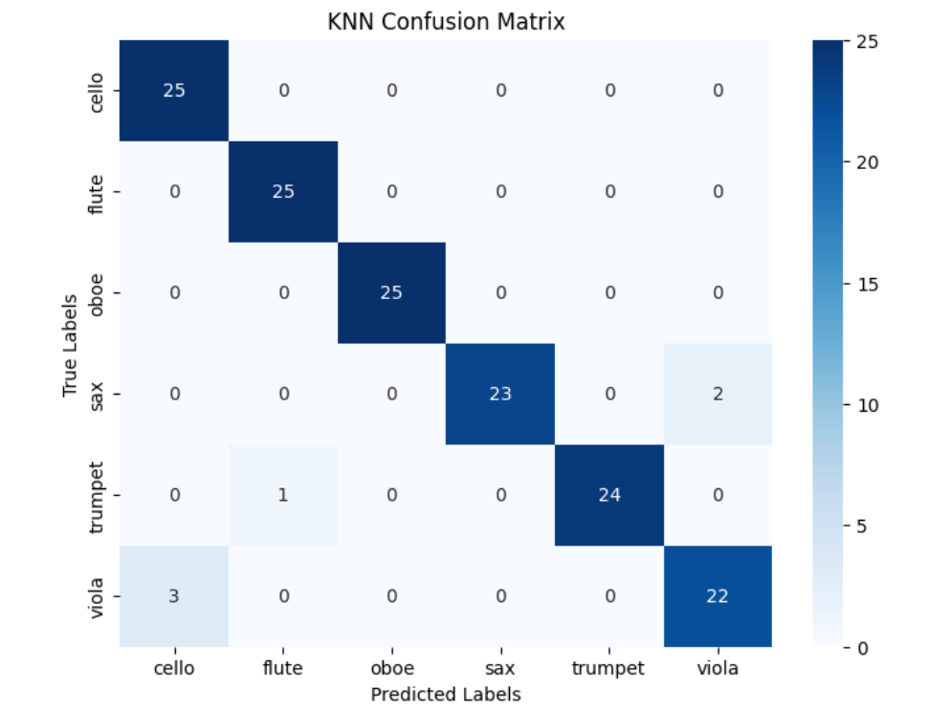
Figure 5.1.2. KNN Confusion Matrix

The KNN model achieves a high accuracy of 96%, showing excellent performance in classifying musical instruments. Most instruments have high precision, recall, and F1-scores, indicating reliable and balanced predictions. Overall, KNN with MFCC features is effective for musical instrument classification.

5.2. SVM Linear Classifier
Table 5.2.1 SVM Linear Classification Report
 | Precision | Recall | F1-Score | Support
  Class
Cello | 0.89 | 1.00 | 0.94 | 25
Flute | 0.80 | 0.80 | 0.80 | 25
Oboe | 0.89 | 0.96 | 0.92 | 25
Sax | 0.96 | 0.88 | 0.92 | 25
Trumpet | 0.84 | 0.84 | 0.84 | 25
Viola | 0.95 | 0.84 | 0.89 | 25
Accuracy |  |  | 0.89 | 150
Macro avg | 0.89 | 0.89 | 0.89 | 150
Weighted avg | 0.89 | 0.89 | 0.89 | 150

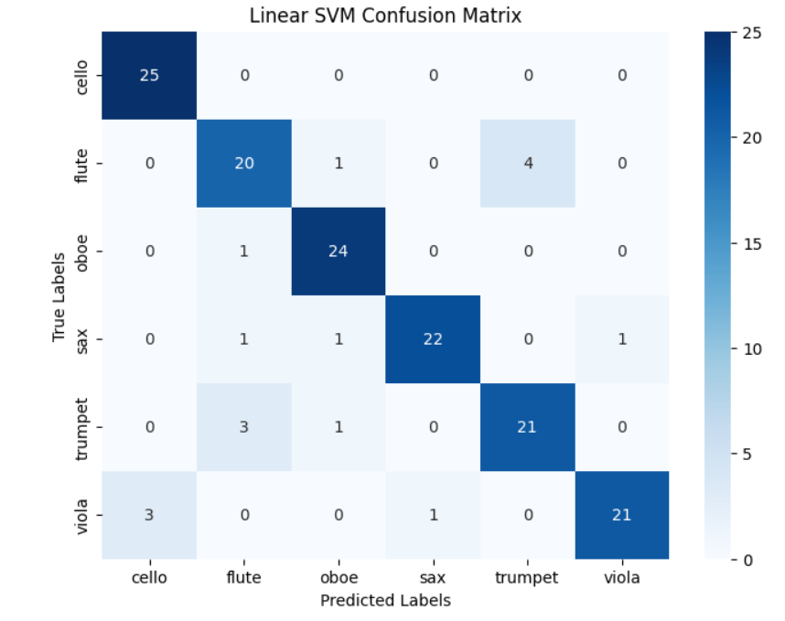Figure 5.2.2. SVM Linear Confusion Matrix
The Linear SVM classification report shows an overall accuracy of 89%, indicating good but slightly lower performance compared to KNN. Most instruments are classified reliably, with cello, oboe, and saxophone showing strong precision and recall, while flute and trumpet have comparatively lower scores. Overall, the Linear SVM model demonstrates consistent and balanced performance across all instrument classes.

5.3. RBF SVM Classifier
Table 5.3.1 RBF SVM Classification Report
 | Precision | Recall | F1-Score | Support
  Class
Cello | 0.93 | 1.00 | 0.96 | 25
Flute | 1.00 | 1.00 | 1.00 | 25
Oboe | 1.00 | 1.00 | 1.00 | 25
Sax | 1.00 | 0.96 | 0.98 | 25
Trumpet | 1.00 | 1.00 | 1.00 | 25
Viola | 0.96 | 0.92 | 0.94 | 25
Accuracy |  |  | 0.98 | 150
Macro Avg | 0.98 | 0.98 | 0.98 | 150
Weighted Avg | 0.98 | 0.98 | 0.98 | 150

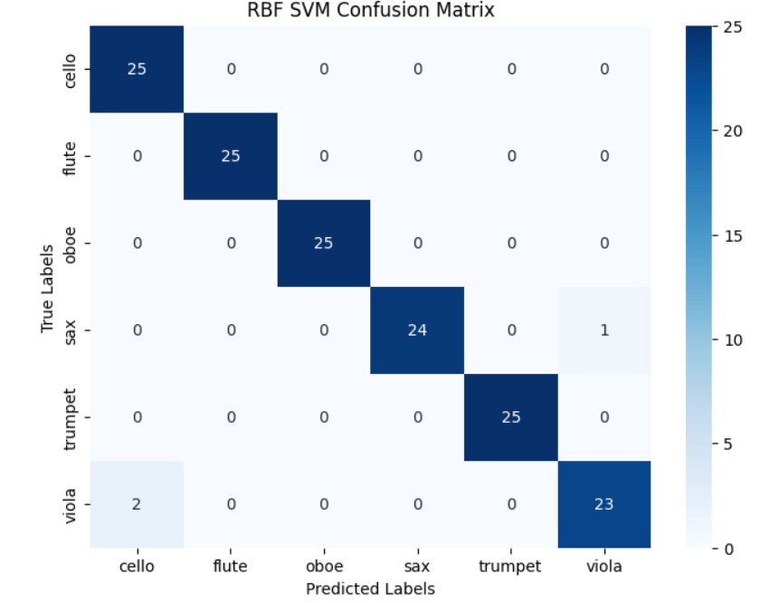
Figure 5.3.2. RBF SVM Confusion Matrix

The SVM with RBF kernel achieves an excellent overall accuracy of 98%, showing superior performance in classifying musical instruments. Most instruments, including flute, oboe, and trumpet, achieve perfect precision and recall, indicating very accurate predictions. This demonstrates that the RBF kernel effectively captures the non-linear patterns in MFCC features, leading to highly reliable classification results.

5.4. XGBoost Classifier
Table 5.4.1 XGBoost Classification Report
 | Precision | Recall | F1-Score | Support
  Class
Cello | 0.92 | 0.96 | 0.94 | 25
Flute | 0.86 | 0.96 | 0.91 | 25
Oboe | 1.00 | 0.88 | 0.94 | 25
Sax | 0.92 | 0.92 | 0.92 | 25
Trumpet | 0.88 | 0.92 | 0.90 | 25
Viola | 0.91 | 0.84 | 0.88 | 25
Accuracy |  |  | 0.91 | 150
Macro Avg | 0.92 | 0.91 | 0.91 | 150
Weighted Avg | 0.92 | 0.91 | 0.91 | 150

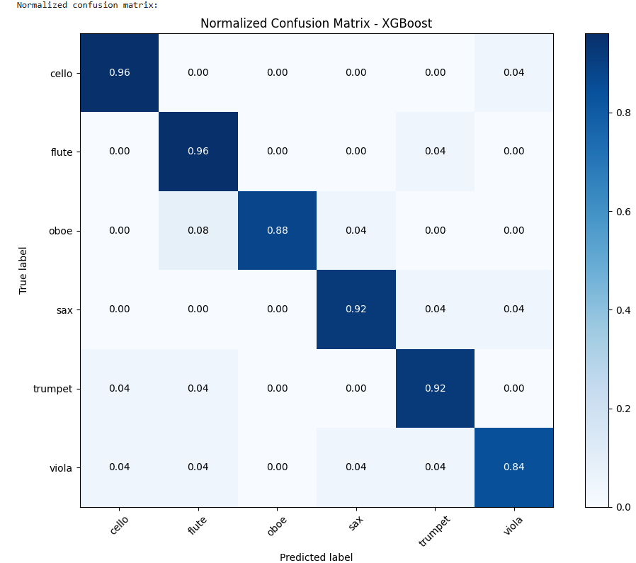
Figure 5.4.2. XGBoost Confusion Matrix
The XGBoost classification report shows an overall accuracy of 91%, indicating good performance in musical instrument classification. Most instruments achieve balanced precision and recall, with cello and oboe showing strong results, while a few classes exhibit minor confusion. Overall, XGBoost provides reliable classification performance but is slightly less accurate than SVM with RBF kernel for this task.

5.5 AdaBoost Classifier
Table 5.5.1 AdaBoost Classification Report
 | Precision | Recall | F1-Score | Support
  Class
Cello | 0.68 | 0.52 | 0.59 | 25
Flute | 0.50 | 0.76 | 0.60 | 25
Oboe | 0.62 | 0.40 | 0.49 | 25
Sax | 0.64 | 0.64 | 0.64 | 25
Trumpet | 0.65 | 0.60 | 0.62 | 25
Viola | 0.45 | 0.52 | 0.48 | 25
Accuracy |  |  | 0.57 | 150
Macro Avg | 0.59 | 0.57 | 0.57 | 150
Weighted Avg | 0.59 | 0.57 | 0.57 | 150

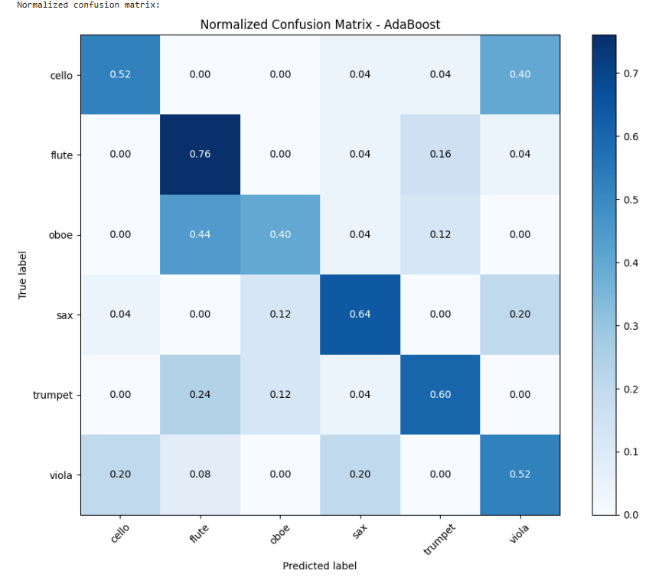
Figure 5.5.2 AdaBoost Confusion Matrix
The AdaBoost classification report shows a lower overall accuracy of 57%, indicating weaker performance compared to other models. Several instruments have low precision and recall values, suggesting higher misclassification and confusion between classes. Overall, AdaBoost is less effective for this musical instrument classification task using the given audio features.

5.6. Accuracy Comparison
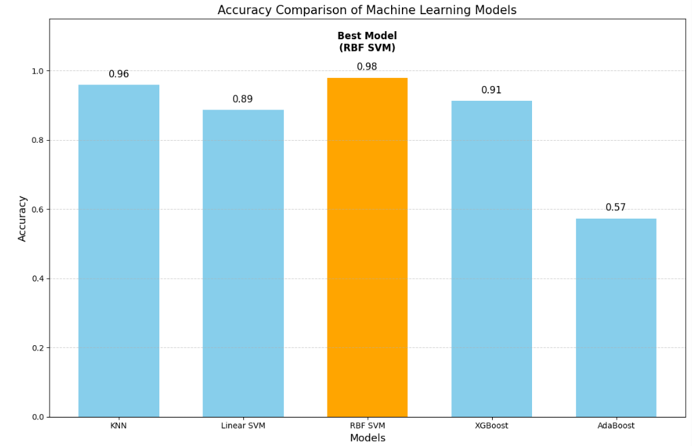
Figure 5.6.1 Accuracy Comparison of Machine Learning

The bar chart compares the accuracy of different machine learning models used for musical instrument classification. RBF SVM achieves the highest accuracy (98%), making it the best-performing model, followed by KNN and XGBoost. AdaBoost shows the lowest accuracy, indicating it is less suitable for this task compared to the other models.

5.7 Desktop Application Integration for Music Instrument Classification
To make the music instrument classification system easy to use, a simple desktop application was developed using Python Tkinter for the graphical user interface and a machine learning model at the backend. This application allows users to classify musical instruments directly from audio files without needing any technical knowledge of signal processing or machine learning. The interface is designed to be user-friendly, where users can simply select an audio file and instantly view the predicted instrument. The application loads the trained components at startup, including the feature scaler, label encoder, and the RBF SVM model saved using Joblib. When the user clicks the Select Audio button, a file dialog opens, allowing them to choose an audio file. Once selected, the audio signal is processed using Librosa, where it is normalized and converted into meaningful features using Mel-spectrograms and MFCCs. These features are averaged and standardized to match the format used during training. After feature extraction, the processed data is passed through the scaler and then fed into the trained model to predict the instrument class.
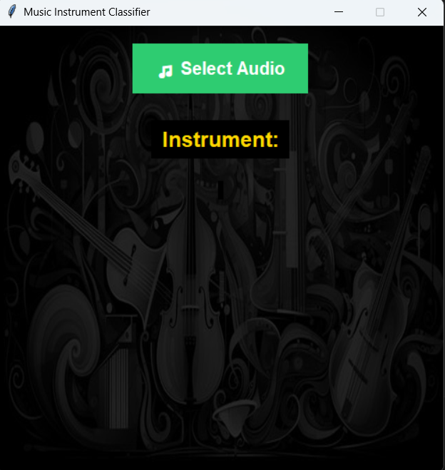

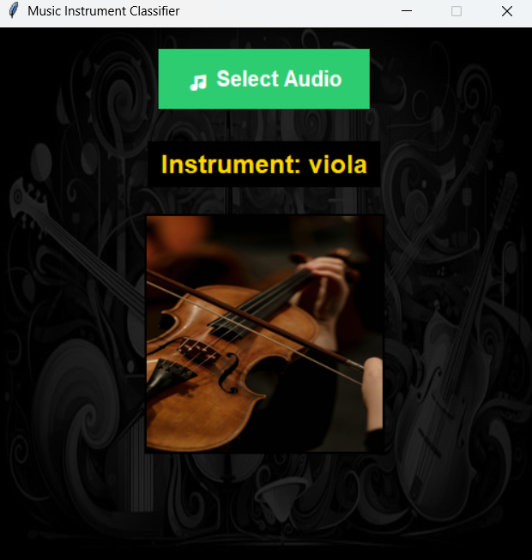

Figure 5.7.1 Desktop Application Integration for Music Instrument Classification
6. Conclusion and Future Scope

6.1. Conclusion
This project focuses on the automatic classification of musical instruments using machine learning techniques. Audio recordings of six instruments—saxophone, flute, cello, trumpet, oboe, and viola—were processed using Mel-Frequency Cepstral Coefficients (MFCCs) to extract meaningful audio features. Multiple classification models, including KNN, Linear SVM, RBF SVM, AdaBoost, and XGBoost, were trained and evaluated. The experimental results showed high classification accuracy, with SVM-based and ensemble models performing particularly well. Feature scaling and proper data splitting ensured reliable and unbiased evaluation. Overall, the study confirms that MFCC-based machine learning models are effective for multi-class musical instrument recognition.

6.2. Limitations
Despite the encouraging results, the proposed system has certain limitations. First, the dataset size is relatively limited, which may restrict the model’s ability to generalize to unseen recordings recorded under different acoustic conditions. Second, the system relies solely on MFCC features, which, while effective, may not capture all temporal and harmonic characteristics of musical instruments.

6.2. Future Scope
The scope of this work can be extended in several directions. Future research may focus on expanding the dataset by including more instruments, larger sample sizes, and recordings from diverse environments. Additional audio features such as chroma features, spectral contrast, or tempo-based descriptors can be combined with MFCCs to improve classification accuracy.

References

[1] Prabavathy, S., Rathikarani, V., & Dhanalakshmi, P. (2020). Classification of Musical Instruments using SVM and KNN. International Journal of Innovative Technology and Exploring Engineering, 9(7), 1186-1190.
[2] Gulhane, S. R., Shirbahadurkar Suresh, D., & Badhe Sanjay, S. (2020). Identification of musical instruments using mfcc features. In New Trends in Computational Vision and Bio-inspired Computing: Selected works presented at the ICCVBIC 2018, Coimbatore, India (pp. 957-968). Cham: Springer International Publishing.
[3] Deng, G., & Ko, Y. C. (2022). Active learning music genre classification based on support vector machine. Advances in Multimedia, 2022(1), 4705272.
[4] Sanchez-Spinola, L. F., Castañon-Guerrero, F., Rodriguez-Montoya, C. A., Cantu-Ortiz, F. J., & Ceballos-Cancino, H. G. (2023, February). Musical Instrument Classification Using k-Nearest Neighbors. In International Congress on Information and Communication Technology (pp. 529-539). Singapore: Springer Nature Singapore.
[5] Chandrashekar, H., Swetha, K. T., Ambika, V., Puttegowda, K., Kumara, B., Paramesha, R., & Parameshachari, B. D. (2025, August). Music Instruments Classification Using Signal Processing and Machine Learning. In 2025 Third International Conference on Networks, Multimedia and Information Technology (NMITCON) (pp. 1-7). IEEE.
[6] Folorunso, S. O., Afolabi, S. A., & Owodeyi, A. B. (2022). Dissecting the genre of Nigerian music with machine learning models. Journal of King Saud University-Computer and Information Sciences, 34(8), 6266-6279.

